

**Khulna University of Engineering & Technology**

*Department of*

Electronics and Communication Engineering

Report on

***Open Ended Lab Project***

Course Title: Computer Networks Laboratory

Course Code: ECE-4110

Submitted To

**Md. Foysal**

Assistant Professor

Department of Electronics and Communication Engineering,

Khulna University of Engineering & Technology

**Shah Muhammad Azmat Ullah**

Lecturer

Department of Electronics and Communication Engineering,

Khulna University of Engineering & Technology

Submitted By

**Md Sajib Rahman**

Roll: 1909028

Year: 4th Term: 1st

Session: 2022-2023

*Date of Submission: June 5, 2024*

Contents

1.Question 3

2.Objectives 4

3.Introduction 4

4.Software & Hardware Used 4

5.Procedure 5

5.1 Basic Structure 5

5.2 Switch & Router Protection 6

5.3 Implementation of DHCP Protocol 6

5.4 Placement of a web server & a DNS Server 6

5.5 Application of Dynamic Routing Protocol (RIP) 8

5.6 Creation of VLAN 8

5.7 Application of ACL (Network Denial) 9

6.Results & Discussion 9

7.Conclusion 10

# **1.Question**

Design a campus network consisting of two or three departments and an admin office using CISCO

packet tracer simulation software. The network topology must meet the following requirements:

1. All switches and routers should be password protected.
2. One of the departments would use the DHCP protocol to assign the IP addresses to all hosts of that network.
3. One of the departments would contain a VLAN system to separate students and faculties networks.
4. A web server and a DNS server should be placed under the admin office.
5. Any of your known dynamic routing protocols should be applied in the designed topology.
6. Apply your desired ACL in routers to access the resources of the admin office. (For example, permit/deny any host/network to access the web server or any host in the admin office)

# 2.Objectives

* To design a campus network consisting of two departments and an admin office using CISCO Packet Tracer simulation software.
* To protect all the switches and routers by using passwords in the simulated network.
* To implement DHCP Protocol to assign the IP addresses to all the hosts dynamically.
* To implement VLAN system to separate two networks.
* To place a web server and a DNS server.
* To apply a dynamic routing protocol.
* To implement and testify ACL settings in routers to access the resources of specific network.

# 3.Introduction

In today's interconnected world, robust and secure network infrastructure is crucial for any organization, particularly in academic settings where the exchange of information is constant and varied. This project focuses on designing and implementing a comprehensive campus network that provides the diverse needs of different departments within an educational institution.

Using CISCO Packet Tracer simulation software, we have created a network topology that represents a typical university campus, consisting of two departments and an administrative office. This design aims to showcase our understanding and application of various networking concepts and protocols learned throughout the ECE 4110: Computer Networks Laboratory course.

Our network design incorporates several key features to ensure efficient operation, enhanced security, and proper resource allocation such as Network Security, Dynamic Host Configuration, Network Segmentation, Centralized Services, Advanced Routing, Access Control etc.

This report will detail our design choices, configuration steps, and the rationale behind each decision. By the end, we aim to demonstrate our proficiency in network design, configuration, and troubleshooting skills that are essential for any aspiring network engineer.

# 4.Software & Hardware Used

* CISCO Packet Tracer simulation software
* PC Configuration

Processor: Intel core i5 8th gen.

Ram: 8 Gb

Rom: 120 Gb

OS: Windows 10

# 5.Procedure

## 5.1 Basic Structure

The topology is composed of three routers. One is for CSE Department. One is for EEE Department and another one is for Admin office.

* Firstly, for CSE Department we have used 3 PCs as end devices which is connected to a switch and the switch is connected to a router.
* Then we have created an admin office network where 2 PCs and 2 servers are placed under a switch which is connected to another router.
* Lastly, for EEE Department we have taken two different switches under another different router. Two switches are used for creating VLAN.

Here is the topology we are dealing with

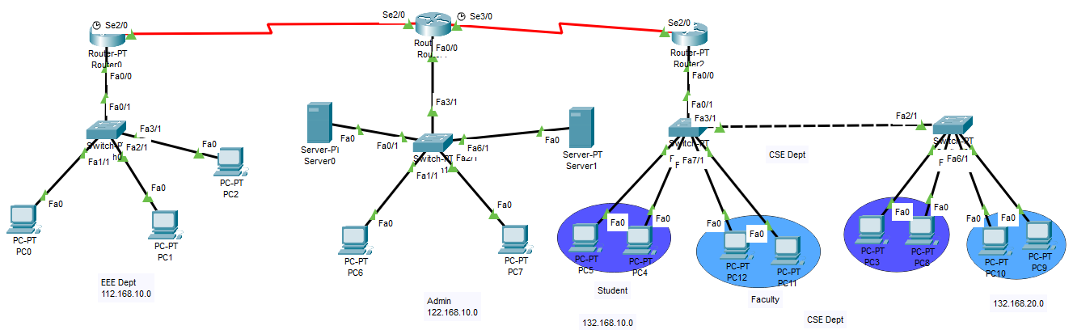

Fig 1.1: The designed network topology

## 5.2 Switch & Router Protection

* For router0 the password is given ‘EEE’ & ‘class’ by the following code:

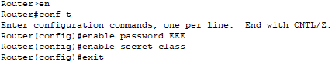

* Similarly, for router1 and router2 and for all four switches, passwords are set.

## 5.3 Implementation of DHCP Protocol

* Using the code DHCP protocol is used in EEE Dept router. Under this router all PCs obtain their IP address dynamically.
* For EEE Department, the network address I have taken is 112.168.10.0 & the default gateway is 112.168.10.1
* Example of one host is given below.

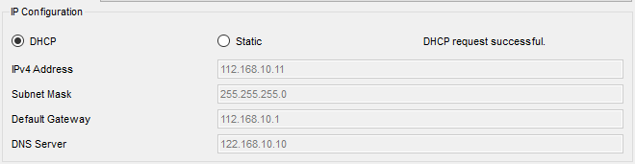

Fig 1.2: IP address allocation using DHCP protocol.

## 5.4 Placement of a web server & a DNS Server

* A web server is placed under the Admin Office router setting the IP address as 122.168.10.2 and default gateway is 122.168.10.1
* From any network, using web browser of PCs the html file can be accessed by the IP address of the web server.
* For DNS server, I’ve added another server having the IP address of 122.168.10.10 and default gateway is 122.168.10.1. Here in settings, I’ve turned the DNS service on and in other PC I’ve set the DNS server fixed as 122.168.10.10. Using DNS server rather putting IP address in the browser search box, we can access the web page typing index.html.

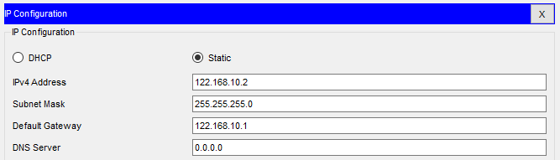

Fig 1.3: IP address of web server

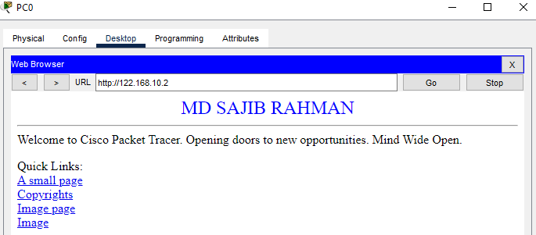

Fig 1.4: Accessing the web server using IP address form the PC of EEE Dept.

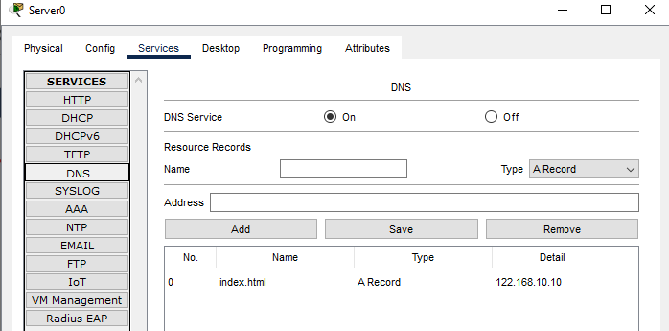

Fig 1.5: Settings of DNS server

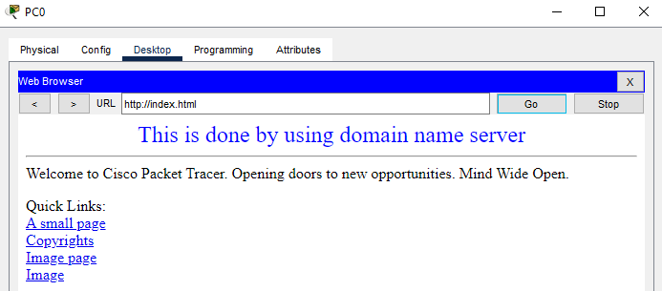

Fig 1.6: Accessing the DNS server typing index.html

## Application of Dynamic Routing Protocol (RIP)

* I have used RIP protocol for dynamic routing in all three routers. Before applying RIP protocol I’ve set the IP address at all serial interfaces & all fast ethernet interfaces connected with the router.
* For RIP protocol at router0, following code is used.

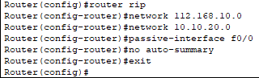

* Similarly, at router1 & router2 RIP router protocol is used.

## Creation of VLAN

* VLAN is created under CSE Dept to separate faculties and students’ network.
* For this I’ve used two switches. In both switches students and faculties are connected.
* For faculty, IP address starts from 132.168.10.11 and for students IP address starts from 132.168.20.11

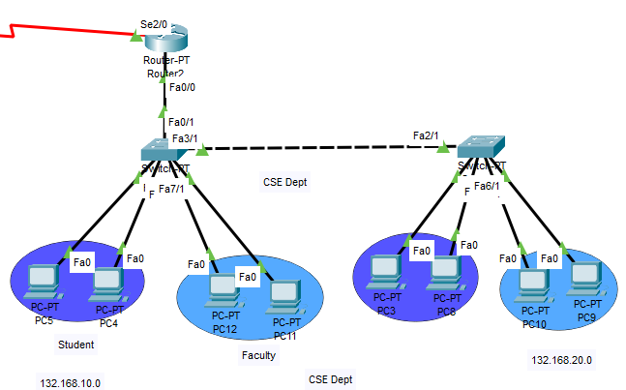

Fig1.7: VLAN in CSE Dept

## Application of ACL (Network Denial)

* Here I have applied ACL for denying CSE Dept students to access EEE Dept Network and vice versa.

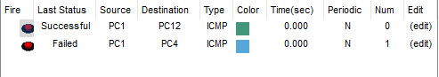

Fig 1.8: Packet transfer between faculty of CSE & other networks possible but between students of CSE & other networks not possible after ACL

# 6.Results & Discussion

The campus network designed and implemented using CISCO Packet Tracer simulation software met almost all the requirements. The network topology, consisting of two departments (CSE and EEE) and an admin office, showed good functionality, security, and efficient resource allocation.

Network Security: All switches and routers were successfully password-protected. For example, Router0 in the EEE department was secured with the passwords 'EEE' and 'class'. Router1 in the Admin Office was secured with the passwords 'ADMIN' and 'class'. Router2 in the CSE department was secured with the passwords 'CSE' and 'class'.

Dynamic Host Configuration: The DHCP protocol was successfully implemented in the EEE Department's router. As shown in Figure 1.2, hosts in this network automatically obtained their IP addresses from the predefined pool (112.168.10.0/24), with 112.168.10.1 as the default gateway. This automation streamlines network management, reducing manual configuration errors and simplifying the addition of new devices.

Network Segmentation: In the CSE Department, VLANs were effectively used to separate faculty and student networks. Despite being connected to the same physical switches, faculty devices (with IP addresses starting from 132.168.10.11) and student devices (starting from 132.168.20.11) were logically isolated. This segmentation enhances both security and performance by reducing broadcast domains and preventing unauthorized access between groups.

Centralized Services: The web server (122.168.10.2) and DNS server (122.168.10.10) were successfully placed under the admin office network. As demonstrated in Figures 1.3 and 1.6, these servers were accessible from other networks. Users could access web content either by directly using the web server's IP address or by typing "index.html".

Advanced Routing: The RIP (Routing Information Protocol) was successfully implemented across all three routers. This dynamic routing protocol enables routers to automatically learn and update their routing tables, ensuring efficient packet forwarding even if network changes occur. The consistent application across all routers ensures seamless inter-department communication.

Access Control: Access Control Lists (ACLs) were effectively applied to enforce network access policies. Specifically, the configuration successfully denied CSE Department students access to the EEE Department network, and vice versa. This granular control over network access enhances security by preventing unauthorized resource use and potential misuse. But here an issue was found and that is it was supposed to block only CSE Dept students by EEE Dept Network but CSE Dept Network also got blocked by Admin Office network.

# 7.Conclusion

This open-ended lab project, focused on designing a comprehensive campus network using CISCO Packet Tracer, has been a scope for understanding of networking concepts & real life implementation from our ECE 4110 course. Our design for a university campus comprising two departments and an admin office met all requirements, including password protected devices, DHCP implementation, VLAN segmentation, centralized server resources, RIP dynamic routing, and ACL-based access control. Working with CISCO Packet Tracer provided hands-on experience, bridging theory and practice. The skills and insights gained will be crucial as we move forward in our careers, equipping us to design and maintain the robust networks that power our interconnected world.

The GitHub link for simulation file is attached here:

https://github.com/sajibrahmansl25/Computer-Networks-Laboratoty